AI Prompt: Explain different projections of maps, their advantages and disadvantages in the language of a 15 year old. Show pictures/links.
2.0 Pro Experimental. Lacks access to real-time info and some Gemini features.

Okay, let's break down map projections. Imagine you have a perfectly round orange (the Earth). Now imagine you want to peel it and make the peel perfectly flat without ripping or stretching it. Impossible, right? That's the basic problem with map projections. We're trying to take a sphere (Earth) and represent it on a flat surface (a map). Since you can't do that perfectly, all map projections have distortions. They mess up something – either the shapes of countries, the sizes, the distances, or the directions.
Different projections choose different compromises. It's like deciding which part of the orange peel you're okay with ripping a little to make the rest look better.
Here are a few common types, explained simply, with their pros and cons:
1. Mercator Projection (showing 3D shape on 2D image - like shadow):
- How it's made: Imagine wrapping a cylinder of paper around the Earth, touching it at the Equator. You "project" the Earth's features onto the cylinder, then unroll it.
Imagine this cylinder unrolling:
- What it looks like: Mercator Projection
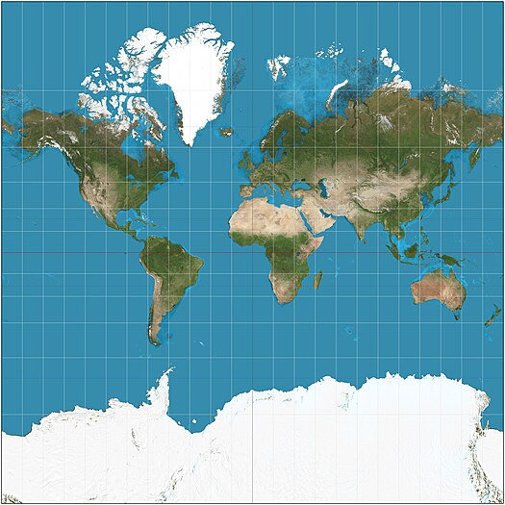
- Advantages:
  - Shapes are preserved (saved) locally: Small areas look pretty much like they should. A small island will look like the right shape.
  - Directions are accurate: Lines of longitude and latitude are straight and meet at right angles. This is GREAT for navigation (sailing, flying). If you draw a straight line on a Mercator map, it represents a constant compass bearing.
- Disadvantages:
  - Size is horribly (very badly) distorted (out of shape), especially near the poles: Greenland looks HUGE, almost as big as Africa, but it's actually much, much smaller. Antarctica looks like it wraps around the entire world! This is the biggest problem with Mercator. It gives a very misleading (wrong) impression (understanding or expression) of the relative sizes of countries.
- Think of it like: Great for sailing or seeing what a small area looks like, but TERRIBLE for understanding the real size of countries far from the equator.
2. Gall-Peters Projection:
- How it's made: This is also a cylindrical projection, but it's designed to fix the size problem of the Mercator. It's like squishing the cylinder a bit before unrolling it.
Gall-Peters creation visualization The little circles show how the projection distorts.
- What it looks like: Gall-Peters Projection
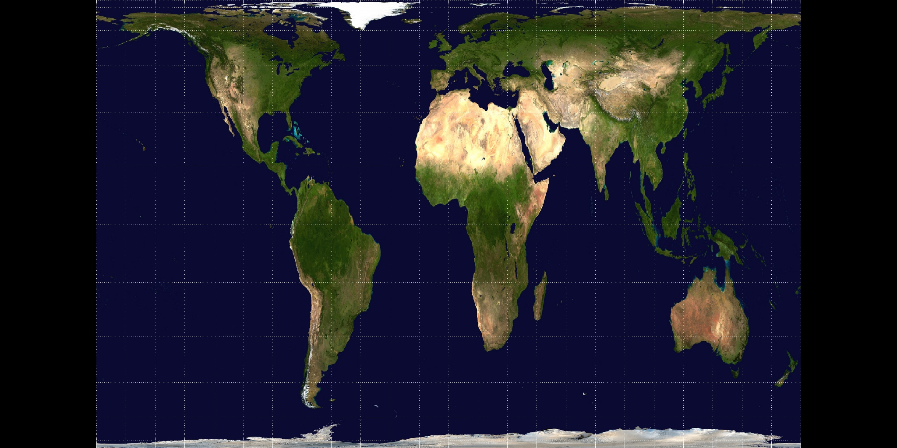
- Advantages:
  - Areas are accurate: Countries are shown in their correct relative sizes. Africa looks much bigger than Greenland, which is accurate (perfect). This is good for comparing land areas.
- Disadvantages:
  - Shapes are very distorted: Everything looks stretched and squished (పిసికేసినట్టు), especially near the Equator. Africa and South America look much longer and thinner than they really are.
- Think of it like: Great for showing the true size of countries, but TERRIBLE for getting a sense of their actual shape.
3. Winkel Tripel Projection:
- How it's made: This one is a bit more mathematically complicated. It's not cylindrical, conical, or azimuthal (those are the three main types of projections). It's a "compromise" projection that tries to minimize all three types of distortion (area, shape, and distance) at once. "Tripel" refers to minimizing the three distortions.
The complex math behind it - You don't need to understand the equations!
- What it looks like: Winkel Tripel Projection
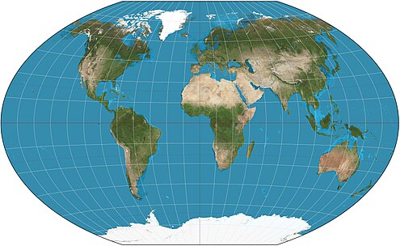
- Advantages:
  - Good balance of distortions: It doesn't do any one thing perfectly, but it minimizes (decrease, reduce) all the errors. It's a good "all-around" projection.
  - Visually appealing: Most people find it looks "right." (because it looks like Earth)
- Disadvantages:
  - Not perfect at anything: It's not equal-area (like Gall-Peters), it's not conformal (shape-preserving, like Mercator), and it doesn't have perfectly accurate distances.
  - Directions are not consistent. Straight lines do not show compass bearings.
- Think of it like: A good "jack-of-all-trades" map. It's the one the National Geographic Society uses a lot.
4. Robinson Projection:
- How it is made: Similar to the Winkel Tripel, is not defined by geometric projection but through a table of coordinates.
- What it looks like Robinson Projection
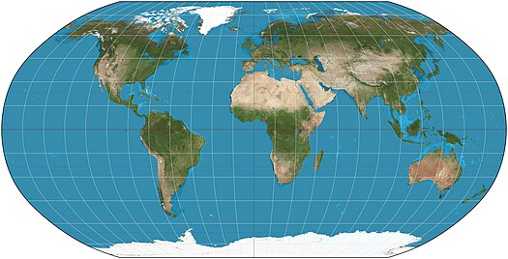
- Advantages:
  - Minimizes distortion, leading to a more accurate depiction (drawing) of the world.
  - Visually appealing (looking good), which contributes (gives) to its popularity.
- Disadvantages:
  - While distortions are minimized, they are not eliminated (remove).
  - Not suitable (fit) for precise (accurate, right, correct) measurements or navigation.
- Think of it like: This map is similar to the Winkel Tripel, a jack-of-all-trades, but another author made it.
5. Azimuthal Equidistant Projection:
- How it's made: Imagine placing a flat piece of paper on the Earth, touching it at one point (usually the North or South Pole). You then project outwards from that point.
Azimuthal Projection creation visualization
- What is looks like: Azimuthal Equidistant Projection
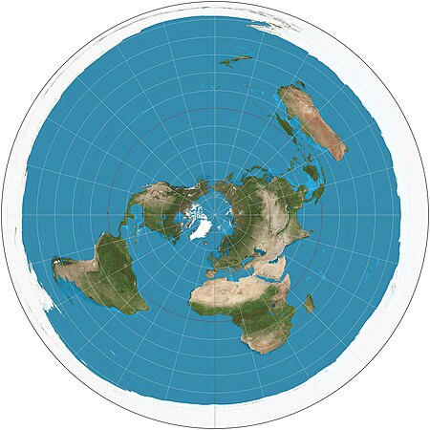
- Advantages:
  - Distances from the center point are accurate: If the center is the North Pole, then all distances measured from the North Pole are correct.
  - Directions from the center point are accurate: Lines radiating out from the center point show the correct direction to any other place.
- Disadvantages:
  - Shape and area are very distorted as you get further from the center point: Things near the edges look extremely stretched and misshapen (distorted; out of shape).
- Think of it like: Great for seeing distances and directions from one specific place, but terrible for comparing anything else. Often used for maps of the polar regions. Also used for radio and aviation because it helps plot the shortest route (a straight line on this map from the center).
Key Takeaway:
There's no perfect map projection. Every map lies (Does some mistakes)! They all distort something. The best projection to use depends on what you need the map for. If you need to navigate, Mercator is good. If you need to compare the sizes of countries, Gall-Peters is better. If you want a good overall picture, Winkel Tripel or Robinson are good choices. Always think about why a particular map was made and what distortions it might have.
—--------------------------------------------------------------------------------—-------------------------------------
AI Prompt: Explain about latitudes and longitudes, and their names.
2.0 Pro Experimental. Lacks access to real-time info and some Gemini features.
Okay, let's explore latitude and longitude! Think of them as Earth's address system. Just like your house has a street address, any location on Earth can be pinpointed using latitude and longitude coordinates.
I can't create new images, but I can guide you to some excellent visuals and explain everything clearly.

1. Latitude (The "Ladder" Lines):
- What they are: Imaginary horizontal lines that circle the Earth, running parallel to the Equator. Think of them like the rungs of a ladder ("ladder" sounds a bit like "latitude").
- How they work:
  - The Equator is the starting point, and it's at 0 degrees latitude.
  - As you move north from the Equator, the latitude increases, going from 0° to 90° North (the North Pole).
  - As you move south from the Equator, the latitude also increases, but it's measured in degrees South, going from 0° to 90° South (the South Pole).
  - Each degree of latitude is about 69 miles (111 kilometers) apart. This distance is relatively constant (it varies slightly because the Earth isn't a perfect sphere, but it's close enough for most purposes).
- Key Names:
  - Equator (0°): The most important latitude line, dividing the Earth into the Northern and Southern Hemispheres (½ of a sphere).
  - Tropic of Cancer (23.5° North): The northernmost point where the sun can be directly overhead (on the June solstice).
  - Tropic of Capricorn (23.5° South): The southernmost point where the sun can be directly overhead (on the December solstice).
  - Arctic Circle (66.5° North): The southernmost latitude in the Northern Hemisphere where the sun can remain continuously above or below the horizon for 24 hours (the "midnight sun (Sun at 12:00 AM in the night)" or "polar night").
  - Antarctic Circle (66.5° South): The northernmost latitude in the Southern Hemisphere where the sun can remain continuously above or below the horizon for 24 hours.

  - The area between Tropic of Cancer and Tropic of Capricorn is called the Torrid Zone or Tropical region.
  - The area between the Tropic of Cancer and Arctic Circle, and between the Tropic of Capricorn and Antarctic Circle is called the Temperate Zone.
  - The areas within the Arctic Circle and Antarctic Circle are called the Frigid Zone.
- Visual: Latitude lines visualization Notice how the lines are parallel and run east-west, but they measure distance north or south of the Equator.
2. Longitude (The "Long" Lines):
- What they are: Imaginary vertical lines that run from the North Pole to the South Pole. They are also called meridians.
- How they work:
  - Unlike latitude, there's no natural "starting point" like the Equator. So, we arbitrarily chose a line called the Prime Meridian.
  - The Prime Meridian (0° Longitude) runs through Greenwich, England (specifically, the Royal Observatory (Like a museum)). This was decided by international agreement in 1884.
  - As you move east from the Prime Meridian, longitude increases from 0° to 180° East.
  - As you move west from the Prime Meridian, longitude also increases, but it's measured in degrees West, going from 0° to 180° West.
  - 180° East and 180° West are the same line, directly opposite the Prime Meridian. This is called the International Date Line (more on that in a bit!).
  - The distance between lines of longitude varies. At the Equator, they are furthest apart (about 69 miles, like latitude). As you move towards the poles, they get closer and closer together until they all meet at the poles.
- Key Names:
  - Prime Meridian (0°): The starting point for measuring longitude.
  - International Date Line (mostly 180° Meridian - but slightly zig zags): This line is mostly along the 180° meridian, but it zig-zags a bit to avoid dividing countries. When you cross the International Date Line going west, you add a day. When you cross it going east, you subtract a day. This is necessary to keep our calendar consistent with the Earth's rotation.
- Visual: Longitude lines visualization Notice how the lines are not parallel. They all meet at the poles. They run north-south, but they measure distance east or west of the Prime Meridian.
3. Putting it Together: Coordinates
- Any location on Earth can be described by its latitude and longitude coordinates. These are usually written as (Latitude, Longitude).
- Example:
  - New York City: (40.7° N, 74.0° W) – This means New York City is 40.7 degrees north of the Equator and 74.0 degrees west of the Prime Meridian.
  - Sydney, Australia: (33.9° S, 151.2° E) – This means Sydney is 33.9 degrees south of the Equator and 151.2 degrees east of the Prime Meridian.
- Degrees, Minutes, and Seconds: For more precise locations, degrees can be further divided into minutes (') and seconds ("). There are 60 minutes in a degree, and 60 seconds in a minute. This is similar to how we divide hours into minutes and seconds.
  - Example: The precise location of the Eiffel Tower is approximately 48°51'29.6"N 2°17'40.2"E. This uses degrees, minutes, and seconds.
In Summary
Latitude and longitude create a grid system that covers the entire Earth. Latitude lines run east-west and measure distance north or south of the Equator. Longitude lines run north-south and measure distance east or west of the Prime Meridian. Together, they provide a unique address for any point on our planet.

—--------------------------------------------------------------------------------—-------------------------------------

AI Prompt: Explain what is a continent vs. country and oceans vs. seas vs. lakes. Name the continents and oceans from biggest to smallest

Okay, let's break down these geographical terms and then list the continents and oceans by size.
1. Continents vs. Countries
- Continent: A continent is a very large, continuous landmass, generally separated from other continents by oceans. Think of them as the biggest "chunks" of land on Earth. They are defined by convention (general agreement) more than any super-strict scientific rules. This means that what counts as a "continent" can sometimes be a bit debatable, but there's a widely accepted list.
- Country: A country is a politically defined region, typically with its own government, laws, and often a shared culture and history. Countries can be within continents. Many countries can exist on a single continent. Some countries are islands (and therefore surrounded by water), and some countries are landlocked (surrounded by other countries). A country has defined borders, while a continent's borders are usually the coastlines.
  - Example: Africa is a continent. Nigeria, Egypt, and South Africa are countries located on the continent of Africa.
2. Oceans vs. Seas vs. Lakes
- Ocean: Oceans are the largest bodies of saltwater on Earth. They are vast (huge, big) and deep, covering most of the planet's surface. They are interconnected, meaning you could theoretically sail from one ocean to another without crossing land (though you might need to go through a narrow passage).
- Sea: Seas are also bodies of saltwater, but they are smaller than oceans and are often partially enclosed by land. Think of a sea as being somewhat like a "bay" or "gulf" of a larger ocean, but on a much bigger scale. Seas are often connected to an ocean, but they have their own distinct characteristics (like different marine life, currents, or salinity).
  - Example: The Mediterranean Sea is largely surrounded by Europe, Asia, and Africa, but it connects to the Atlantic Ocean through the Strait of Gibraltar. The Caribbean Sea is bordered by North and South America and connects to the Atlantic Ocean.
- Lake: Lakes are bodies of water (usually freshwater, but there are some saltwater lakes) that are completely surrounded by land. They are not directly connected to an ocean or sea (though they may be fed by rivers or streams that eventually flow into an ocean). Lakes can vary dramatically in size, from small ponds to huge bodies of water.
  - Example: Lake Superior (in North America) is a very large freshwater lake. The Caspian Sea (between Asia and Europe) is actually the world's largest lake, but it's called a "sea" because it's salty.
Continents (Biggest to Smallest, by land area):
- Asia: The largest continent, with a huge variety of cultures, climates, and landscapes.
- Africa: Known for its diverse wildlife, deserts, and savannas.
- North America: Includes countries like Canada, the United States, and Mexico.
- South America: Home to the Amazon rainforest and the Andes Mountains.
- Antarctica: The southernmost continent, almost entirely covered in ice.
- Europe: A smaller but densely populated continent with a long history. Sometimes, Europe and Asia are considered a single continent called Eurasia.
- Australia: The smallest continent, also a country itself. Sometimes grouped with nearby islands to form a region called Oceania.
Oceans (Biggest to Smallest, by surface area):
- Pacific Ocean: The largest and deepest ocean, covering more area than all the continents combined.
- Atlantic Ocean: The second-largest, separating the Americas from Europe and Africa.
- Indian Ocean: Mostly in the Southern Hemisphere, known for its warm waters.
- Southern (Near Antarctica ; in the South Pole) Ocean (or Antarctic Ocean): Surrounds Antarctica. This one is sometimes debated – some consider it just the southern parts of the Pacific, Atlantic, and Indian Oceans.
- Arctic Ocean: The smallest and shallowest ocean, mostly covered in sea ice.
Important Note: "Biggest" can be measured in different ways (area, volume, depth). These lists are based on surface area, which is the most common way to compare.

—--------------------------------------------------------------------------------—-------------------------------------

AI Prompt: Summarize this document and all the important details to remember for an 8 year old kid.
Maps:
- Imagine trying to flatten (to make it flat, or straight like a paper) a ball. That's what making a map is like! We can't do it perfectly, so maps always have some mistakes.
- Different maps show different things best. Some are good for showing shapes, some for sizes, and some for directions.
- Mercator maps are good for sailing but make places near the poles look HUGE.
- Gall-Peters maps show the right size of countries but make them look stretched.
- Winkel Tripel and Robinson maps are good all-around maps visually, but can’t be used for navigation.
Latitude and Longitude:
- These are like Earth's addresses!
- Latitude lines go around the Earth like belts and tell you how far north or south you are from the middle (the Equator).
- Longitude lines go from the North Pole to the South Pole and tell you how far east or west you are from a special line in England (the Prime Meridian).
- Latitudes are full circles, while longitudes are semicircles.
- Together, they help you find any place on Earth!
Continents and Oceans:
- Continents are big pieces of land. There are 7: Asia, Africa, North America, South America, Antarctica, Europe, and Australia. Asia is the biggest.
- Countries are like neighborhoods inside continents.
- Oceans are HUGE bodies of saltwater. There are 5: Pacific, Atlantic, Indian, Southern, and Arctic. The Pacific is the biggest.
- Seas are smaller parts of oceans.
- Lakes are bodies of water surrounded by land and usually have fresh water.

—--------------------------------------------------------------------------------—-------------------------------------
AI Prompt: Create a homework exercise with 30 questions on this topic with multiple choice questions, fill in the blanks, matching etc.
- What is a common problem with all map projections?
a) They are too colorful
b) They always have some distortions
c) They are too small
d) They are too expensive
- Which map projection is best known for preserving accurate directions, making it useful for navigation?
a) Gall-Peters Projection
b) Winkel Tripel Projection
c) Mercator Projection
d) Robinson Projection
- Which projection shows the correct relative sizes of countries but distorts their shapes?
a) Mercator Projection
b) Robinson Projection
c) Winkel Tripel Projection
d) Gall-Peters Projection
- What does latitude measure?
a) Distance east or west of the Prime Meridian
b) Distance north or south of the Equator
c) Elevation above sea level
d) Time zones
- What is the starting point for measuring longitude?
a) The Equator
b) The International Date Line
c) The Prime Meridian
d) The North Pole
- Which is the largest continent?
a) Africa
b) Europe
c) Asia
d) North America
- Which is the largest ocean?
a) Atlantic Ocean
b) Indian Ocean
c) Arctic Ocean
d) Pacific Ocean
- What are smaller parts of oceans often called?
a) Lakes
b) Rivers
c) Seas
d) Ponds
- Which latitude line divides the Earth into the Northern and Southern Hemispheres?
a) Tropic of Cancer
b) Tropic of Capricorn
c) Equator
d) Arctic Circle
- What is another name for longitude lines?
a) Parallels
b) Meridians
c) Circles
d) Belts
II. Fill in the Blanks:
- The ______________ Projection is often used for general world maps because it balances distortions.
- The ______________ is at 0 degrees latitude.
- The ______________ runs through Greenwich, England.
- ______________ are bodies of water completely surrounded by land.
- ______________ is the southernmost continent, mostly covered in ice.
- The ______________ is the line where you add or subtract a day when you cross it.
- The area between Tropic of Cancer and Tropic of Capricorn is called the ______________ Zone.
- Lines of ______________ run from the North Pole to the South Pole.
- ______________ are politically defined regions within continents.
- The ______________ Ocean surrounds Antarctica.
III. Matching:
- Match the map projection with its main characteristic:
  - Mercator Projection
  - Gall-Peters Projection
  - Winkel Tripel Projection
  - A. Shows accurate area but distorts shapes
  - B. Good for navigation, distorts sizes at poles
  - C. Balances distortions, good all-around map
- Match the geographical term with its description:
  - Continent
  - Country
  - Sea
  - D. A politically defined region
  - E. A large, continuous landmass
  - F. A smaller part of an ocean, often partially enclosed by land
- Match the latitude line with its degree:
  - Equator
  - Tropic of Cancer
  - Arctic Circle
  - Tropic of Capricorn
  - G. 23.5° North
  - H. 0°
  - I. 66.5° North
  - J. 23.5° South

